**Mage AI:**

Mage AI empowers us to build and manage efficient data pipelines.expand_more Its user-friendly interface and comprehensive features make data processing effortless.expand_more

**Key Features:**

* **Intuitive Drag-and-Drop Interface:** Construct data pipelines visually without writing complex code.expand_more
* **Streamlined Data Processing:** Manage and automate various data manipulation tasks.
* **Seamless Integration:** Connects to diverse data sources and cloud platforms for smooth data flow.expand_more
* **Enhanced Collaboration:** Facilitate teamwork on data pipelines with version control and easy sharing.expand_more

**Benefits:**

* **Increased Efficiency:** Shorten development time and streamline data processing workflows.expand_more
* **Improved Accuracy:** Reduce errors and ensure data consistency throughout the pipeline.expand_more
* **Scalability:** Effortlessly handle growing data volumes without complexity.expand_more
* **Collaboration Made Easy:** Foster productive teamwork with shared data pipelines.

**Mage AI: Effortless Data Loading**

Mage AI simplifies data loading from various sources into our data pipelines. Here's a closer look at its data loading functionalities:

**Data Loader Blocks:**

* **Pre-built Templates:** Mage AI provides pre-built templates for popular data sources like databases, cloud storage, and APIs. These templates streamline configuration and reduce manual coding [invalid URL removed].
* **Customizable Code:** Us can write custom Python code to handle data loading from unique sources or tailor the loading process to our specific needs.
* **Data Loader Clients:** Mage AI offers built-in clients for common data sources, including:
  + **Databases:** MySQL, PostgreSQL, OracleDB, etc. [invalid URL removed]
  + **Cloud Storage:** AWS S3, Google Cloud Storage, etc. [invalid URL removed]
  + **File Systems:** Local and remote file systems [invalid URL removed]
  + **APIs:** Leverage web APIs as data sources [invalid URL removed]

**Benefits of Mage AI Data Loading:**

* **Simplified Configuration:** Pre-built templates make data loading from common sources effortless.
* **Flexibility:** Handle diverse data sources with ease, including custom integrations.
* **Scalability:** Efficiently load large datasets for big data processing.
* **Reduced Errors:** Minimize errors through code-driven and templated configurations.

**Mage AI Transformations: Tailoring Our Data**

Mage AI offers robust data transformation capabilities to cleanse, enrich, and reshape our data for analysis. Here's a breakdown of its transformation features:

**Transformer Blocks:**

* **Modular and Reusable:** Pre-built functions for common data transformations like filtering, cleaning, and aggregations. These blocks reduce repetitive coding and streamline workflows <https://docs.mage.ai/design/blocks/transformer>.
* **Pandas Integration:** Transformations leverage pandas DataFrames, providing a familiar and powerful way to manipulate data on a row-by-row basis <https://docs.mage.ai/design/blocks/transformer>.
* **Customizable:** Us can create custom transformer blocks to handle specific data manipulation needs.

**Key Transformation Capabilities:**

* **Data Cleaning:** Address missing values, inconsistencies, and formatting issues to ensure data quality.
* **Data Derivation:** Create new columns based on calculations or manipulations of existing data.
* **Data Aggregation:** Summarize data using functions like sum, mean, or count for insightful analysis.
* **Data Joining and Merging:** Combine data from multiple sources for a comprehensive view.

**Benefits of Mage AI Transformations:**

* **Improved Data Quality:** Clean and consistent data leads to more reliable analysis.
* **Enhanced Efficiency:** Pre-built blocks and familiar tools save development time.
* **Flexibility:** Handle diverse data manipulation needs with ease.
* **Scalability:** Efficiently transform large datasets for big data applications.

**Mage AI: Delivering Insights Through Data Export**

Mage AI empowers us to export our transformed data to various destinations, making analysis and sharing results a breeze. Here's what us need to know about data export in Mage AI:

**Data Exporter Blocks:**

* **Modular Design:** Similar to transformers, Mage AI utilizes data exporter blocks for a well-structured approach to data export. These blocks handle the logic of sending our data to the desired location <https://docs.mage.ai/development/blocks/data_exporters/templates>.
* **Variety of Options:** Mage AI offers built-in support for exporting data to:
  + **File Systems:** Save our data locally or on remote file systems for further analysis or sharing <https://docs.mage.ai/development/blocks/data_exporters/templates>.
  + **Cloud Storage:** Export data to cloud storage platforms like AWS S3 or Google Cloud Storage for scalability and accessibility <https://docs.mage.ai/development/blocks/data_exporters/templates>.
  + **Databases:** Load our transformed data into databases for data warehousing or visualization purposes <https://docs.mage.ai/development/blocks/data_exporters/templates>.
  + **Custom Destinations:** Create custom exporter blocks to send data to unique destinations like email or reporting tools <https://docs.mage.ai/development/blocks/data_exporters/templates>.

**Benefits of Mage AI Data Export:**

* **Flexibility:** Choose the most suitable destination based on our needs, from local storage to cloud platforms.
* **Streamlined Analysis:** Easily export data for further analysis in tools like BI platforms or data visualization tools.
* **Collaboration:** Share exported data with colleagues for collaborative decision-making.
* **Scalability:** Efficiently export large datasets to cloud storage for big data applications.

**SELECTING TABLES FROM DIFFERENT DATABASE USING PYTHON:**

To select tables from different databases, we can navigate to the YAML configuration file and add the details of the respective databases. This will enable access and select tables from those databases.

Once you have added and saved the database details, we can select the table name as shown in the screenshot below.

REF: <https://blog.thecloudside.com/mage-ai-the-easy-way-to-automate-your-data-pipelines-1c8b01315eb4>

**Unit Testing in Mage AI**

Mage AI primarily focuses on building data pipelines visually, but it still allows to write unit tests for custom code blocks might create. Here's what we need to know about unit testing in Mage AI:

**Why Unit Test in Mage AI?**

* **Ensure Custom Block Functionality:** If we develop custom transformer or data loader blocks with Python code, unit testing guarantees they work as expected with various inputs.
* **Improve Code Quality:** Unit tests help identify potential issues early in the development process, leading to more robust and reliable custom code.

**How to Unit Test in Mage AI:**

**Create unit tests and run tests in CI/CD pipeline.**

We can create a tests folder in your project folder and put unit tests in this folder.

In your CI/CD pipeline, you can cd into the project’s folder and run the following command to run unit tests.

python3 -m unittest discover -s tests --failfast

<https://docs.mage.ai/streaming/destinations/postgres>

**Customer segmentation**

Customer segmentation is the practice of dividing a company’s customers into groups that reflect similarity among customers in each group. The goal of segmenting customers is to decide how to relate to customers in each segment in order to maximize the value of each customer to the business.

**Advantages of customer segmentation**

Implementing customer segmentation leads to plenty of new business opportunities. We can do a lot of optimizations in:

* budgeting,
* product design,
* promotion,
* marketing,
* customer satisfaction.

Let’s discuss these benefits in more depth.

* **Budgeting**

Nobody likes to invest in campaigns that don’t generate any new customers. Most companies don’t have huge marketing budgets, so that money has to be spent right. Segmentation enables we to target customers with the highest potential value first, so we get the most out of our marketing budget.

* **Product design**

Customer segmentation helps we understand what our users need. We can identify the most active users/customers and optimize our application/offer towards their needs.

* **Promotion**

Properly implemented customer segmentation helps we plan special offers and deals. Frequent deals have become a staple of e-commerce and commercial software in the past few years. If we reach a customer with just the right offer, at the right time, there’s a huge chance they’re going to buy. Customer segmentation will help we tailor our special offers perfectly.

* **Marketing**

The marketing strategy can be directly improved with segmentation because we can plan personalized marketing campaigns for different customer segments, using the channels that they use the most.

* **Customer satisfaction**

By studying different customer groups, we learn what they value the most about our company. This information will help we create personalized products and services that perfectly fit our customers’ preferences.

In the next section, we’re going to discuss why machine learning for customer segmentation.

**Machine Learning for customer segmentation**

Machine learning methodologies are a great tool for analyzing customer data and finding insights and patterns. Artificially intelligent models are powerful tools for decision-makers. They can precisely identify customer segments, which is much harder to do manually or with conventional analytical methods.

There are many machine learning algorithms, each suitable for a specific type of problem. One very common **machine learning algorithm that’s suitable for customer segmentation problems is the k-means clustering algorithm**. There are other clustering algorithms as well such as DBSCAN, Agglomerative Clustering, and BIRCH, etc.

**Implementing K-means clustering in Python**

K-Means clustering is an efficient machine learning algorithm to solve data clustering problems. It’s an unsupervised algorithm that’s quite suitable for solving customer segmentation problems. Before we move on, let’s quickly explore two key concepts

**Unsupervised Learning**

Unsupervised machine learning is quite different from supervised machine learning. It’s a special kind of machine learning algorithm that discovers patterns in the dataset from unlabeled data.

Unsupervised machine learning algorithms can group data points based on similar attributes in the dataset. One of the main types of unsupervised models is clustering models.

**Implementing K-means clustering in Python**

K-Means clustering is an efficient machine learning algorithm to solve data clustering problems. It’s an unsupervised algorithm that’s quite suitable for solving customer segmentation problems. Before we move on, let’s quickly explore two key concepts.

**Unsupervised Learning**

Unsupervised machine learning is quite different from supervised machine learning. It’s a special kind of machine learning algorithm that discovers patterns in the dataset from unlabeled data.

Unsupervised machine learning algorithms can group data points based on similar attributes in the dataset. One of the main types of unsupervised models is clustering models.

Note that, supervised learning helps us produce an output from the previous experience.

**Clustering algorithms**

A clustering machine learning algorithm is an unsupervised machine learning algorithm. It’s used for discovering natural groupings or patterns in the dataset. It’s worth noting that clustering algorithms just interpret the input data and find natural clusters in it.

Some of the most popular clustering algorithms are:

* K-Means Clustering
* Agglomerative Hierarchical Clustering
* Expectation-Maximization (EM) Clustering
* Density-Based Spatial Clustering
* Mean-Shift Clustering

In the following section, we’re going to analyze the customer segmentation problem using the k-means clustering algorithm and machine learning. However, before that, let’s quickly discuss why we’re using the k-means clustering algorithm.

**Why use K-means clustering for customer segmentation?**

Unlike supervised learning algorithms, K-means clustering is an unsupervised machine learning algorithm. This algorithm is used when we have unlabeled data. Unlabeled data means input data without categories or groups provided. Our customer segmentation data is like this for this problem.

The algorithm discovers groups (cluster) in the data, where the number of clusters is represented by the K value. The algorithm acts iteratively to assign each input data to one of K clusters, as per the features provided. All of this makes k-means quite suitable for the customer segmentation problem.

Given a set of data points are grouped as per feature similarity. The output of the K-means clustering algorithm is:

* The centroids values for K clusters,
* Labels for each input data point.

**Predictions and Insights Overview**

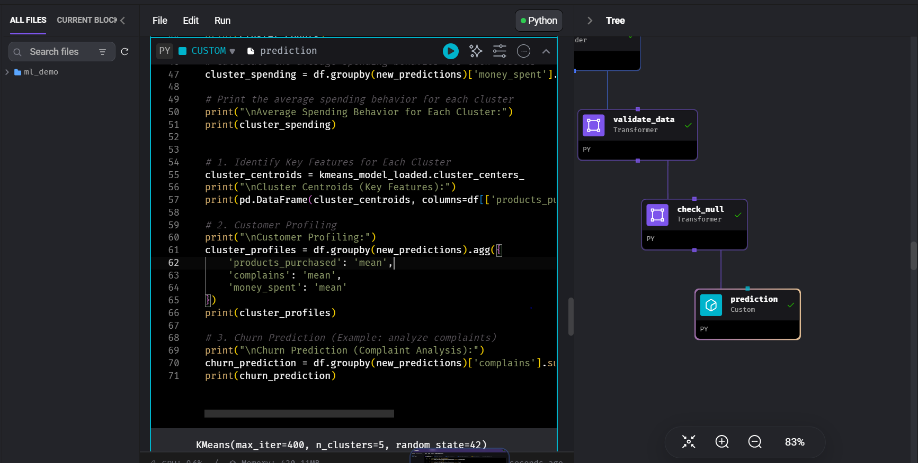

**The segment_customerts function utilizes a trained K-means clustering model to segment customers based on their purchasing behavior, complaints, and spending patterns. It generates predictions and additional insights to aid in customer profiling, churn prediction, and identifying key features for each cluster.**

**1. Average Spending Behavior for Each Cluster**

The analysis calculates the average spending behavior for each customer cluster. This insight helps in understanding the purchasing power and potential revenue contribution of different customer segments.

Example Output:

Cluster 0: $450.20 Cluster 1: $780.60 Cluster 2: $220.40

**2. Key Features for Each Cluster (Cluster Centroids)**

The analysis identifies key features for each customer cluster by examining the cluster centroids. This provides insight into the distinguishing characteristics of each segment, facilitating targeted marketing strategies and product offerings.

Example Output:

| | Products Purchased | Complains | Money Spent | |--------------|--------------------|-----------|-------------| | Cluster 0 | 1.2 | 0.2 | 350.8 | | Cluster 1 | 2.5 | 0.1 | 720.6 | | Cluster 2 | 0.8 | 0.3 | 180.2 |

**3. Customer Profiling**

The analysis profiles customers within each cluster based on their average behavior in terms of products purchased, complaints filed, and money spent. This enables personalized marketing campaigns and tailored customer experiences.

Example Output:

| | Products Purchased | Complains | Money Spent | |--------------|--------------------|-----------|-------------| | Cluster 0 | 1.2 | 0.2 | $350.8 | | Cluster 1 | 2.5 | 0.1 | $720.6 | | Cluster 2 | 0.8 | 0.3 | $180.2 |

**4. Churn Prediction (Complaint Analysis)**

The analysis predicts customer churn by analyzing the number of complaints filed within each cluster. Higher complaint rates may indicate dissatisfaction and potential churn risk, prompting proactive retention strategies.

Example Output:

Cluster 0: 5 complaints Cluster 1: 2 complaints Cluster 2: 7 complaints